Q9: Write a program to calculate simple and compound interest for given principal, rate, and time.
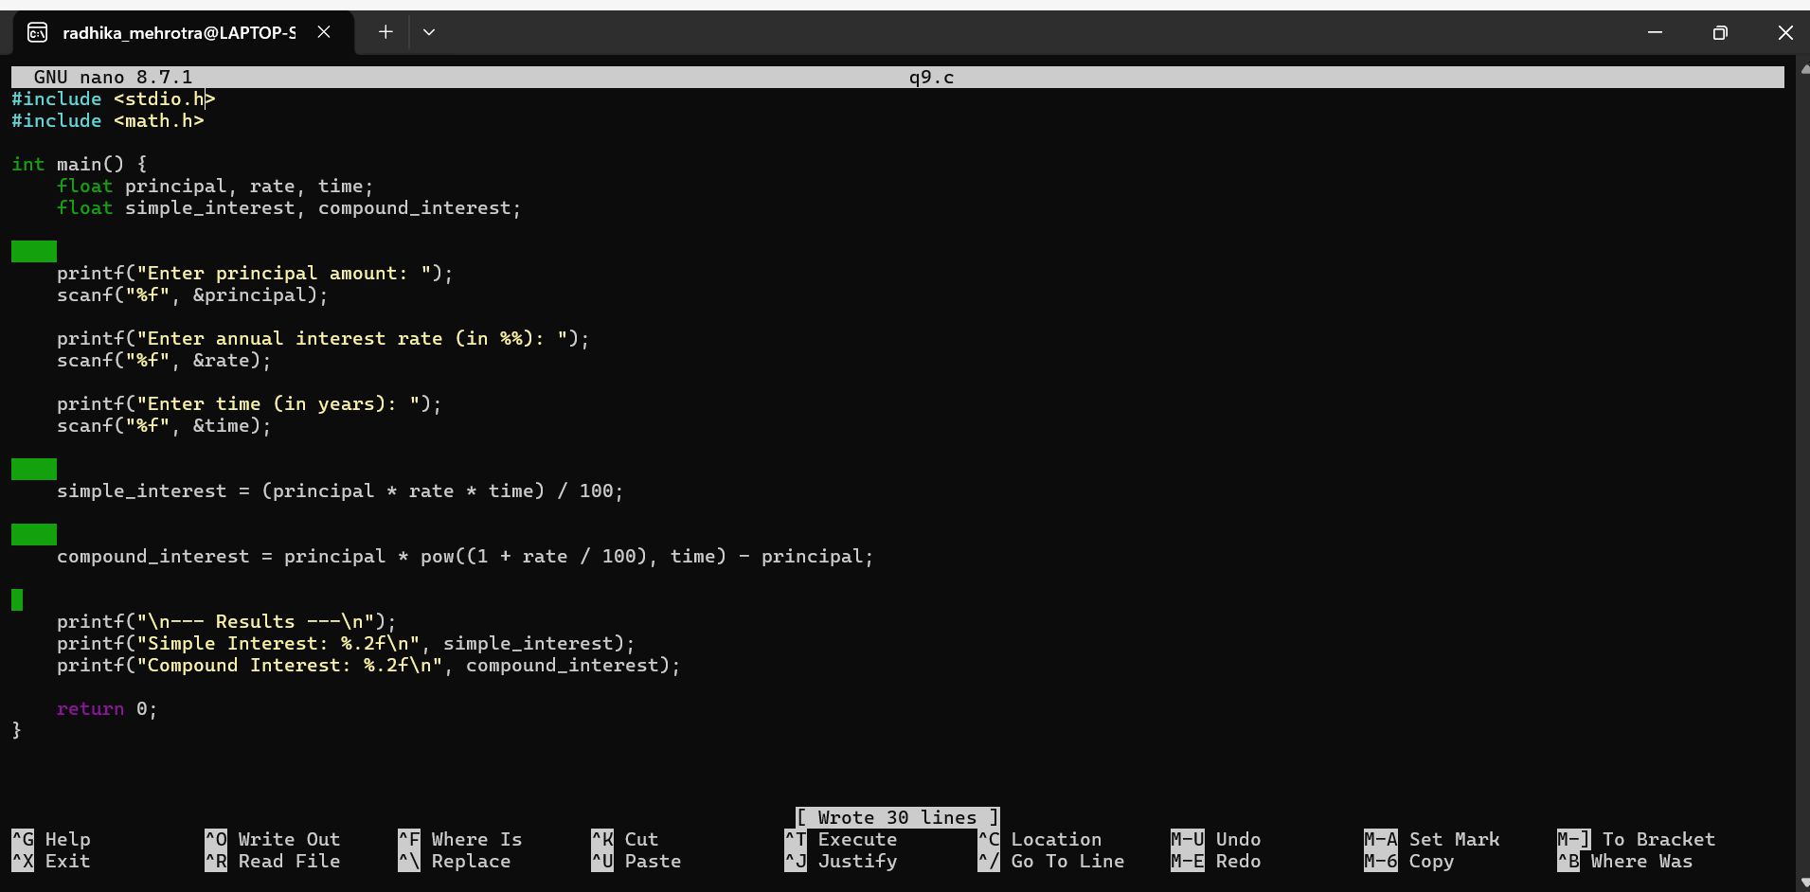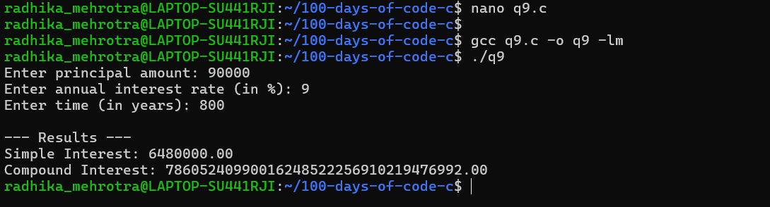Q10: Write a program to input time in seconds and convert it to hours:minutes:seconds format.

